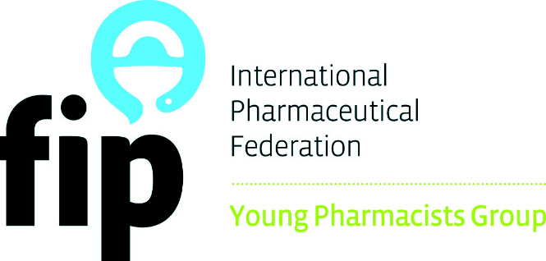

FIP YOUNG PHARMACISTS GROUP

FIP MENTORSHIP PROGRAM

Application Form for
Young Pharmacists and
Pharmaceutical Scientists

2018

INTERNATIONAL
PHARMACEUTICAL
FEDERATION
(FIP)

General Regulations
Description of the Program
The aim of the mentorship program is to provide mentorship for young pharmacists and pharmaceutical scientists who are developing their career. Mentors are intended to provide general advice to the young pharmacist/pharmaceutical scientist about career development. The Mentor/Mentee pair are not intended to be matched perfectly in academic specialty, but rather, have similar pharmacy career path interests.

Application and Procedures
Young pharmacists and pharmaceutical scientists can submit an application that addresses the need for mentorship. The applicant has to clearly specify the issues he/she is facing about his/her career and the expectations from the mentorship program.

Eligibility and Limitations
Only individual members of FIP Young Pharmacists Group (YPG) are eligible to apply.
Each applicant can only submit one application and have only one mentor at the same time.

Application is rolling
The program will be continuous and the applications are accepted anytime.

Matching process
All entries received will be reviewed by a panel nominated by FIP YPG, which will then pass the applications to up to 3 potential mentors. The potential mentors will assess the applications and decide whether to accept the mentee.

The potential mentors will be identified based on three criteria as follows:
The relevance of the themes to the mentor.
The former experiences the applicants have.
The mentorship plan proposed.

Report submissions by program mentees:
- Provide semi-annual personal development reports (no longer than 500 words) to the mentor (1 report every 6 months)
- Participate at least in a quarterly communication with mentor (once every 3 months)
- Complete yearly evaluations of the Mentorship program and of the Mentor.

Report submissions by program mentors:
- Participate at least in a quarterly communication with mentor (once every 3 months)
- Complete yearly evaluations of the Mentorship program and of the Mentee.

The information in this section aims to explain the various parts of this application form.

Applicant
Any young pharmacist or pharmaceutical scientist who is a member of the FIP YPG can apply. This is a one-to-one program. Please apply only on your behalf.

Signature
The signature is the authorization for FIP to review and use the information provided by the applicants for the program. Also by signing this, the applicants understand the terms and obligations in participating the program

Themes
Please select one to three themes that best matches the themes you are involved in and your career plan is. You are free to define new fields that are applicable to your plan. The themes you choose help reviewers and potential mentors have a quick idea of your plan.

Areas of Growth
Please identify your current working/studying field and major tasks, your career plan and the issue or problems you would like to address.

Expectation from the Program
Please describe what you see in this program, what kind of assistance you need and how the mentor can provide such assistance.

Proposed mentorship plan:
The applicant must specify a desired 1-year mentorship plan that includes how often they would like to talk with their mentors.

Submitting the application
Please send your application by email to ypg@fip.org

Details of the applicant
Please attach a short Curriculum Vitae (CV) of the applicant.
Name
FIP Membership Number |  |  | Professional occupation
Street address
Postcode |  |  | City
Region |  |  | Country
E-mail:
Telephone | prefix | number | Fax |  | prefix |  | Number

Signature
By signing this application, the applicant agrees and understand the following terms:
- All information contained in this application is truthful and accurate to the best of your knowledge, and no relevant information has been withheld.
- The applicant is obliged to keep the international pharmaceutical federation and young pharmacists group informed of any changed concerning the mentorship plans
- In the event of a successful match of the mentorship, the applicant is obliged to submit reports and updates as required by the International Pharmaceutical Federation.

I affirm that this application for the Young Pharmacists/Pharmaceutical Scientists’ Mentorship is original and all information provided is truthful and accurate. I further affirm that I have read and understood the rules of the program.

Applicant’s name:
Place |  | Date
Signature

Main themes for the Interests
The topics listed below are examples. The applicant is free to define new themes/subjects applicable to the project.
Please tick () a maximum of 3 boxes ()
International cooperation | Compounding & drug development |  |  | Continuous professional development
Emerging trends in practice | Research & model designs |  |  | E-pharmacy & new technologies
Rural healthcare development | Diagnostics & clinical practice |  |  | Novel community pharmacy services
Access to medication | Pharmaceutical analysis |  |  | Medication management practices
Vaccination services | Biotechnology & pharmacogenetics |  |  | Professional development & promotion
Healthcare promotion | Epidemiology & post market research |  |  | “Seven-star” pharmacist
Managing disease outbreaks | Drug targeting & drug delivery |  |  | Other (specify: )
Anti-drugs/substance abuse | Herbal & traditional medicines |  |  | Other (specify: )
Disadvantaged people | Academia & pharmacy education |  |  | Other (specify: )
Please choose 3 sections or SIGs of FIP that you’re interested in the most. This helps us direct your application.
Please tick () a maximum of 3 boxes ()
Sections: (See http://fip.org/pharmacy_practice for introductions)
Academic pharmacy  Clinical biology  Community pharmacy  Health and medicines information |  | Hospital pharmacy  Industrial pharmacy  Military and emergency pharmacy  Social and administrative pharmacy
Special Interest Groups (See: http://fip.org/pharmaceutical_sciences for introductions)
Drug Design and Discovery  Natural Products  Formulation Design and Pharmaceutical Technology  Pharmacokinetics (PK), Pharmacodynamics (PD) and Systems Pharmacology  Translational Research and Individualized Medicines |  |  | Biotechnology; this SIG currently has 1 focus group: Vaccine  Analytical Sciences and Pharmaceutical Quality; this SIG currently has 1 focus group: Pharmaceutical Enzymes  Pharmacy Practice Research  Regulatory Sciences; this SIG currently has 4 focus groups: Dissolution/In vitro drug release, BCS and Biowaivers, BA/BE and Clinical Bridging Studies

Areas of Growth:
Describe the current area you’re working in and how you plan your future development. (Max. 250 words)

Expectation from the program:
Describe the problem you are facing or the issues you concern now and how the program/mentor can help you (Max. 250 words)

Proposed Mentorship Plan:
Provide a simple plan on how you want to work with your mentor (Max. 250 words)
Note: Participation of FIP Annual Congress is not obligated but highly suggested.

~ Thank you for your application. We will get back to you soon~

